|  |
| --- |
| Idealo |
| TOY ROBOT SIMULATION |
| COMMAND BASED SIMULATOR |
|  |
| **uysharma** |
| **3/2/2018** |

|  |
| --- |
| This document describes implementation of toy robot simulator and tools to test it. |

Introduction

Based on given requirement this document describes the tool requirement to run code, discussion on kind of restful services and manual & unit testing procedure

Requirement

1. IDE : Netbeans or eclipse
2. JDK 1.8
3. Apache Maven 3
4. Important : PORT : 8080

Restful Services

1. **http://localhost:8080**[**/toyRobot/getSimulationReport**](http://localhost:8080/swagger-ui.html#!/rest-toy-robot-controller/getSimulationReportUsingGET)**?command=** PLACE X,Y,F MOVE LEFT

[getSimulationReport](http://localhost:8080/swagger-ui.html" \l "!/rest-toy-robot-controller/getSimulationReportUsingGET)

**Implementation Notes**

Simulate robot and get position report. Command should be like this PLACE X,Y,F MOVE LEFT RIGHT REPORT

Bottom of Form

1. **http://localhost:8080**[**/toyRobot/postSimulationCommand**](http://localhost:8080/swagger-ui.html#!/rest-toy-robot-controller/postSimulationCommandUsingPOST)

[postSimulationCommand](http://localhost:8080/swagger-ui.html" \l "!/rest-toy-robot-controller/postSimulationCommandUsingPOST)

**Implementation Notes**

Give command and table dimension to toy robot simulation Ex. PLACE X,Y,F MOVE LEFT RIGHT REPORT

**Request Format**

**{**

**"matrixColumn": 0,**

**"matrixRow": 0,**

**"toyCommand": "**PLACE X,Y,F MOVE LEFT RIGHT **"**

**}**

**Note: matrixColumn and matrixRow by default set to 5**

1. **http://localhost:8080**[**/toyRobot/fileSimulationCommand**](http://localhost:8080/swagger-ui.html#!/rest-toy-robot-controller/fileSimulationCommandUsingPOST)

[fileSimulationCommand](http://localhost:8080/swagger-ui.html" \l "!/rest-toy-robot-controller/fileSimulationCommandUsingPOST)

**Implementation Notes**

This method receives file in the form of request and reads content of file and produce report. Command should be in the form of Ex. PLACE X,Y,F MOVE LEFT RIGHT REPORT

**Request Format**

**Test.txt**

PLACE X,Y,F MOVE LEFT RIGHT

Testing

# Manual Testing

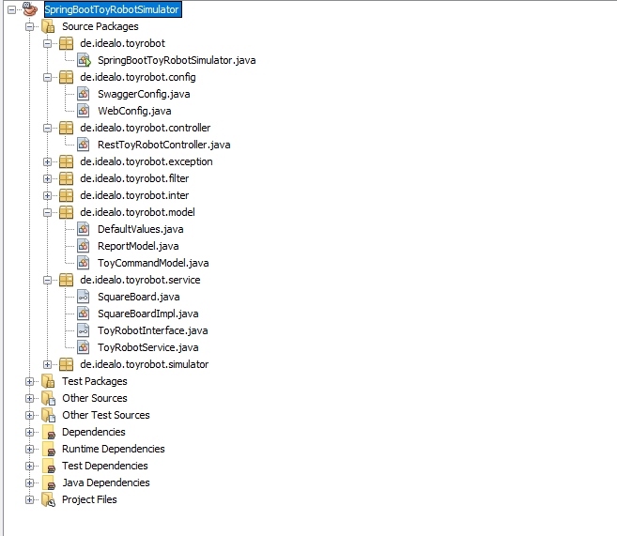

Netbeans

Right click on project and run it

Open Browser and type URL

<http://localhost:8080/swagger-ui.html#!/>

Here you find all three mentioned restful services

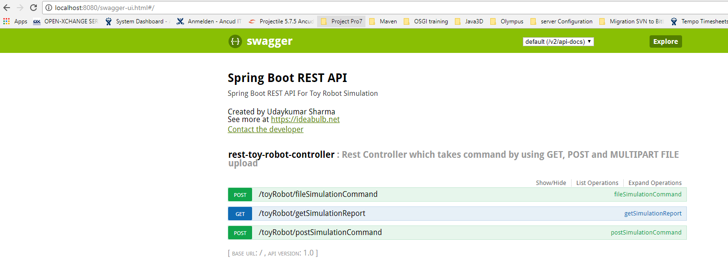

### [/toyRobot/fileSimulationCommand](http://localhost:8080/swagger-ui.html#!/rest-toy-robot-controller/fileSimulationCommandUsingPOST)

### 

Upload file from here

Then click here

**Result**

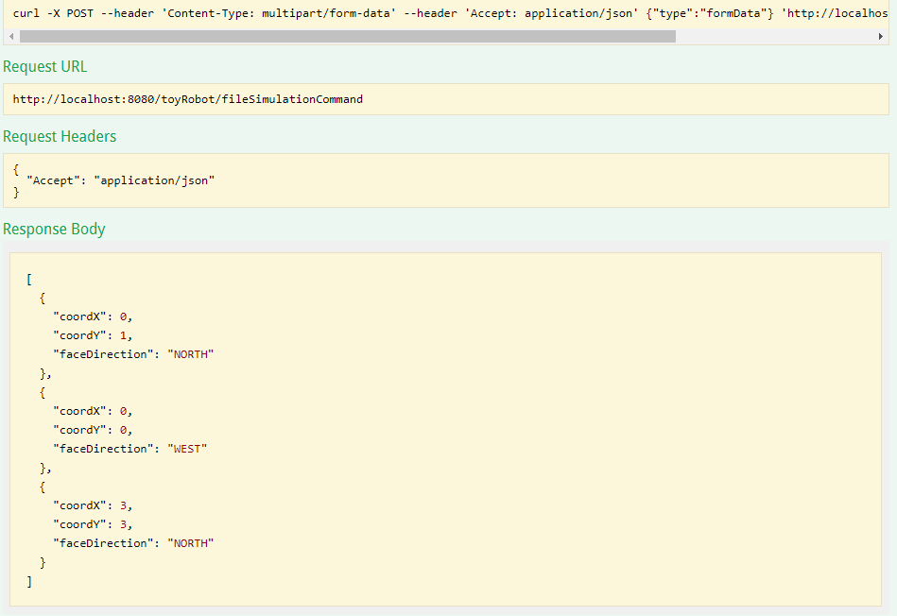

### [/toyRobot/getSimulationReport](http://localhost:8080/swagger-ui.html#!/rest-toy-robot-controller/getSimulationReportUsingGET)

### 

### Result

### 

### [/toyRobot/postSimulationCommand](http://localhost:8080/swagger-ui.html#!/rest-toy-robot-controller/postSimulationCommandUsingPOST)

### 

### Report

### 

# Unit Testing

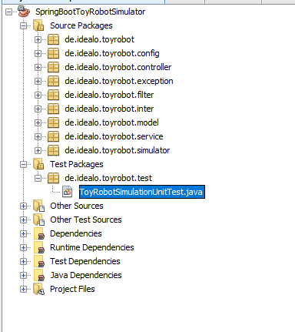

Netbeans

Right click on this file and select test file option

**Logs**

**-------------------------------------------------------**

**T E S T S**

**-------------------------------------------------------**

**Running de.idealo.toyrobot.test.ToyRobotSimulationUnitTest**

**16:04:34,788 |-INFO in ch.qos.logback.classic.LoggerContext[default] - Could NOT find resource [logback.groovy]**

**16:04:34,788 |-INFO in ch.qos.logback.classic.LoggerContext[default] - Found resource [logback-test.xml] at [file:/D:/My%20Data/RobotSimulator/target/test-classes/logback-test.xml]**

**16:04:34,897 |-INFO in ch.qos.logback.classic.joran.action.ConfigurationAction - debug attribute not set**

**16:04:34,916 |-INFO in ch.qos.logback.core.joran.action.AppenderAction - About to instantiate appender of type [ch.qos.logback.core.ConsoleAppender]**

**16:04:34,926 |-INFO in ch.qos.logback.core.joran.action.AppenderAction - Naming appender as [STDOUT]**

**16:04:34,992 |-WARN in ch.qos.logback.core.ConsoleAppender[STDOUT] - This appender no longer admits a layout as a sub-component, set an encoder instead.**

**16:04:34,992 |-WARN in ch.qos.logback.core.ConsoleAppender[STDOUT] - To ensure compatibility, wrapping your layout in LayoutWrappingEncoder.**

**16:04:34,992 |-WARN in ch.qos.logback.core.ConsoleAppender[STDOUT] - See also http://logback.qos.ch/codes.html#layoutInsteadOfEncoder for details**

**16:04:34,993 |-INFO in ch.qos.logback.classic.joran.action.LoggerAction - Setting level of logger [org.springframework] to DEBUG**

**16:04:34,993 |-INFO in ch.qos.logback.classic.joran.action.LoggerAction - Setting additivity of logger [org.springframework] to false**

**16:04:34,993 |-INFO in ch.qos.logback.core.joran.action.AppenderRefAction - Attaching appender named [STDOUT] to Logger[org.springframework]**

**16:04:34,994 |-INFO in ch.qos.logback.classic.joran.action.LoggerAction - Setting level of logger [com.memorynotfound] to DEBUG**

**16:04:34,994 |-INFO in ch.qos.logback.classic.joran.action.LoggerAction - Setting additivity of logger [com.memorynotfound] to false**

**16:04:34,994 |-INFO in ch.qos.logback.core.joran.action.AppenderRefAction - Attaching appender named [STDOUT] to Logger[com.memorynotfound]**

**16:04:34,994 |-INFO in ch.qos.logback.classic.joran.action.RootLoggerAction - Setting level of ROOT logger to DEBUG**

**16:04:34,994 |-INFO in ch.qos.logback.core.joran.action.AppenderRefAction - Attaching appender named [STDOUT] to Logger[ROOT]**

**16:04:34,994 |-INFO in ch.qos.logback.classic.joran.action.ConfigurationAction - End of configuration.**

**16:04:34,995 |-INFO in ch.qos.logback.classic.joran.JoranConfigurator@6ddf90b0 - Registering current configuration as safe fallback point**

**2018-03-02 16:04:35 [main] INFO d.i.toyrobot.service.ToyRobotService - ROBOT ON COORDINATES X=0 Y=0 FACE DIRECTION=NORTH**

**2018-03-02 16:04:35 [main] INFO d.i.toyrobot.service.ToyRobotService - ROBOT FACE LEFT**

**2018-03-02 16:04:35 [main] INFO d.i.toyrobot.service.ToyRobotService - SIMULATION RESULT**

**2018-03-02 16:04:35 [main] INFO d.i.t.c.RestToyRobotController -**

**\*\*\*\*\*\*\*\*\*\*\*\*SECOND REPORT\*\*\*\*\*\*\*\*\*\*\*\*\*\*\*\***

**2018-03-02 16:04:35 [main] INFO d.i.t.c.RestToyRobotController -**

**COMMAND IS PLACE 0,0,NORTH LEFT REPORT**

**2018-03-02 16:04:35 [main] INFO d.i.t.c.RestToyRobotController -**

**REPORT IS {0,0,WEST}**

**2018-03-02 16:04:35 [main] INFO d.i.t.c.RestToyRobotController -**

**\*\*\*\*\*\*\*\*\*\*\*\*\*\*\*\*\*\*\*\*\*\*\*\*\*\*\*\*\*\*\*\*\*\*\*\*\*\*\*\*\*\*\*\***

**2018-03-02 16:04:35 [main] ERROR d.i.t.c.RestToyRobotController - ROBOT MISSING**

**2018-03-02 16:04:35 [main] INFO d.i.toyrobot.service.ToyRobotService - ROBOT ON COORDINATES X=1 Y=2 FACE DIRECTION=EAST**

**2018-03-02 16:04:35 [main] INFO d.i.toyrobot.service.ToyRobotService - ROBOT MOVE ON COORDINATES X=2 Y=2 FACE DIRECTION=EAST**

**2018-03-02 16:04:35 [main] INFO d.i.toyrobot.service.ToyRobotService - ROBOT MOVE ON COORDINATES X=3 Y=2 FACE DIRECTION=EAST**

**2018-03-02 16:04:35 [main] INFO d.i.toyrobot.service.ToyRobotService - ROBOT FACE LEFT**

**2018-03-02 16:04:35 [main] INFO d.i.toyrobot.service.ToyRobotService - ROBOT MOVE ON COORDINATES X=3 Y=3 FACE DIRECTION=NORTH**

**2018-03-02 16:04:35 [main] INFO d.i.toyrobot.service.ToyRobotService - SIMULATION RESULT**

**2018-03-02 16:04:35 [main] INFO d.i.t.c.RestToyRobotController -**

**\*\*\*\*\*\*\*\*\*\*\*\*THIRD REPORT\*\*\*\*\*\*\*\*\*\*\*\*\*\*\*\***

**2018-03-02 16:04:35 [main] INFO d.i.t.c.RestToyRobotController -**

**COMMAND IS PLACE 1,2,EAST MOVE MOVE LEFT MOVE REPORT**

**2018-03-02 16:04:35 [main] INFO d.i.t.c.RestToyRobotController -**

**REPORT IS {3,3,NORTH}**

**2018-03-02 16:04:35 [main] INFO d.i.t.c.RestToyRobotController -**

**\*\*\*\*\*\*\*\*\*\*\*\*\*\*\*\*\*\*\*\*\*\*\*\*\*\*\*\*\*\*\*\*\*\*\*\*\*\*\*\*\*\*\*\***

**2018-03-02 16:04:35 [main] ERROR d.i.toyrobot.service.ToyRobotService - ROBOT IS NOT PLACED**

**2018-03-02 16:04:35 [main] INFO d.i.toyrobot.service.ToyRobotService - SIMULATION RESULT**

**2018-03-02 16:04:35 [main] ERROR d.i.t.c.RestToyRobotController - SEVENTH REPORT COMMAND IS INCORRECT**

**2018-03-02 16:04:35 [main] INFO d.i.toyrobot.service.ToyRobotService - ROBOT ON COORDINATES X=0 Y=0 FACE DIRECTION=NORTH**

**2018-03-02 16:04:35 [main] INFO d.i.toyrobot.service.ToyRobotService - ROBOT MOVE ON COORDINATES X=0 Y=1 FACE DIRECTION=NORTH**

**2018-03-02 16:04:35 [main] INFO d.i.toyrobot.service.ToyRobotService - SIMULATION RESULT**

**2018-03-02 16:04:35 [main] INFO d.i.t.c.RestToyRobotController -**

**\*\*\*\*\*\*\*\*\*\*\*\*FIRST REPORT\*\*\*\*\*\*\*\*\*\*\*\*\*\*\*\***

**2018-03-02 16:04:35 [main] INFO d.i.t.c.RestToyRobotController -**

**COMMAND IS PLACE 0,0,NORTH MOVE REPORT**

**2018-03-02 16:04:35 [main] INFO d.i.t.c.RestToyRobotController -**

**REPORT IS {0,1,NORTH}**

**2018-03-02 16:04:35 [main] INFO d.i.t.c.RestToyRobotController -**

**\*\*\*\*\*\*\*\*\*\*\*\*\*\*\*\*\*\*\*\*\*\*\*\*\*\*\*\*\*\*\*\*\*\*\*\*\*\*\*\*\*\*\*\***

**2018-03-02 16:04:35 [main] INFO d.i.toyrobot.service.ToyRobotService - ROBOT DID NOT PLACED ON TABLE SO NO MOVE**

**2018-03-02 16:04:35 [main] INFO d.i.toyrobot.service.ToyRobotService - ROBOT DID NOT PLACED ON TABLE SO NO REPORT**

**2018-03-02 16:04:35 [main] INFO d.i.toyrobot.service.ToyRobotService - ROBOT ON COORDINATES X=1 Y=2 FACE DIRECTION=EAST**

**2018-03-02 16:04:35 [main] INFO d.i.toyrobot.service.ToyRobotService - ROBOT ON COORDINATES X=0 Y=0 FACE DIRECTION=NORTH**

**2018-03-02 16:04:35 [main] INFO d.i.toyrobot.service.ToyRobotService - ROBOT MOVE ON COORDINATES X=0 Y=1 FACE DIRECTION=NORTH**

**2018-03-02 16:04:35 [main] INFO d.i.toyrobot.service.ToyRobotService - SIMULATION RESULT**

**2018-03-02 16:04:35 [main] INFO d.i.toyrobot.service.ToyRobotService - ROBOT ON COORDINATES X=0 Y=0 FACE DIRECTION=NORTH**

**2018-03-02 16:04:35 [main] INFO d.i.toyrobot.service.ToyRobotService - ROBOT FACE LEFT**

**2018-03-02 16:04:35 [main] INFO d.i.toyrobot.service.ToyRobotService - SIMULATION RESULT**

**2018-03-02 16:04:35 [main] INFO d.i.toyrobot.service.ToyRobotService - ROBOT ON COORDINATES X=1 Y=2 FACE DIRECTION=EAST**

**2018-03-02 16:04:35 [main] INFO d.i.toyrobot.service.ToyRobotService - ROBOT MOVE ON COORDINATES X=2 Y=2 FACE DIRECTION=EAST**

**2018-03-02 16:04:35 [main] INFO d.i.toyrobot.service.ToyRobotService - ROBOT MOVE ON COORDINATES X=3 Y=2 FACE DIRECTION=EAST**

**2018-03-02 16:04:35 [main] INFO d.i.toyrobot.service.ToyRobotService - ROBOT FACE LEFT**

**2018-03-02 16:04:35 [main] INFO d.i.toyrobot.service.ToyRobotService - ROBOT MOVE ON COORDINATES X=3 Y=3 FACE DIRECTION=NORTH**

**2018-03-02 16:04:35 [main] INFO d.i.toyrobot.service.ToyRobotService - SIMULATION RESULT**

**2018-03-02 16:04:35 [main] INFO d.i.t.c.RestToyRobotController -**

**\*\*\*\*\*\*\*\*\*\*\*\*FIFTH REPORT\*\*\*\*\*\*\*\*\*\*\*\*\*\*\*\***

**2018-03-02 16:04:35 [main] INFO d.i.t.c.RestToyRobotController -**

**COMMAND IS MOVE REPORT PLACE 1,2,EAST PLACE 0,0,NORTH MOVE REPORT PLACE 0,0,NORTH LEFT REPORT PLACE 1,2,EAST MOVE MOVE LEFT MOVE REPORT**

**2018-03-02 16:04:35 [main] INFO d.i.t.c.RestToyRobotController -**

**REPORT IS {0,1,NORTH} {0,0,WEST} {3,3,NORTH}**

**2018-03-02 16:04:35 [main] INFO d.i.t.c.RestToyRobotController -**

**\*\*\*\*\*\*\*\*\*\*\*\*\*\*\*\*\*\*\*\*\*\*\*\*\*\*\*\*\*\*\*\*\*\*\*\*\*\*\*\*\*\*\*\***

**2018-03-02 16:04:35 [main] INFO d.i.toyrobot.service.ToyRobotService - ROBOT ON COORDINATES X=0 Y=0 FACE DIRECTION=NORTH**

**2018-03-02 16:04:35 [main] INFO d.i.toyrobot.service.ToyRobotService - ROBOT MOVE ON COORDINATES X=0 Y=1 FACE DIRECTION=NORTH**

**2018-03-02 16:04:35 [main] INFO d.i.toyrobot.service.ToyRobotService - ROBOT MOVE ON COORDINATES X=0 Y=2 FACE DIRECTION=NORTH**

**2018-03-02 16:04:35 [main] INFO d.i.toyrobot.service.ToyRobotService - ROBOT MOVE ON COORDINATES X=0 Y=3 FACE DIRECTION=NORTH**

**2018-03-02 16:04:35 [main] INFO d.i.toyrobot.service.ToyRobotService - ROBOT MOVE ON COORDINATES X=0 Y=4 FACE DIRECTION=NORTH**

**2018-03-02 16:04:35 [main] INFO d.i.toyrobot.service.ToyRobotService - ROBOT MOVE ON COORDINATES X=0 Y=5 FACE DIRECTION=NORTH**

**2018-03-02 16:04:35 [main] INFO d.i.toyrobot.service.ToyRobotService - ROBOT MOVE ON COORDINATES X=0 Y=6 FACE DIRECTION=NORTH NOT POSSIBLE**

**2018-03-02 16:04:35 [main] INFO d.i.toyrobot.service.ToyRobotService - ROBOT MOVE ON COORDINATES X=0 Y=6 FACE DIRECTION=NORTH NOT POSSIBLE**

**2018-03-02 16:04:35 [main] INFO d.i.toyrobot.service.ToyRobotService - ROBOT MOVE ON COORDINATES X=0 Y=6 FACE DIRECTION=NORTH NOT POSSIBLE**

**2018-03-02 16:04:35 [main] INFO d.i.toyrobot.service.ToyRobotService - ROBOT MOVE ON COORDINATES X=0 Y=6 FACE DIRECTION=NORTH NOT POSSIBLE**

**2018-03-02 16:04:35 [main] INFO d.i.toyrobot.service.ToyRobotService - ROBOT MOVE ON COORDINATES X=0 Y=6 FACE DIRECTION=NORTH NOT POSSIBLE**

**2018-03-02 16:04:35 [main] INFO d.i.toyrobot.service.ToyRobotService - ROBOT MOVE ON COORDINATES X=0 Y=6 FACE DIRECTION=NORTH NOT POSSIBLE**

**2018-03-02 16:04:35 [main] INFO d.i.toyrobot.service.ToyRobotService - ROBOT MOVE ON COORDINATES X=0 Y=6 FACE DIRECTION=NORTH NOT POSSIBLE**

**2018-03-02 16:04:35 [main] INFO d.i.toyrobot.service.ToyRobotService - ROBOT MOVE ON COORDINATES X=0 Y=6 FACE DIRECTION=NORTH NOT POSSIBLE**

**2018-03-02 16:04:35 [main] INFO d.i.toyrobot.service.ToyRobotService - ROBOT MOVE ON COORDINATES X=0 Y=6 FACE DIRECTION=NORTH NOT POSSIBLE**

**2018-03-02 16:04:35 [main] INFO d.i.toyrobot.service.ToyRobotService - ROBOT MOVE ON COORDINATES X=0 Y=6 FACE DIRECTION=NORTH NOT POSSIBLE**

**2018-03-02 16:04:35 [main] INFO d.i.toyrobot.service.ToyRobotService - ROBOT MOVE ON COORDINATES X=0 Y=6 FACE DIRECTION=NORTH NOT POSSIBLE**

**2018-03-02 16:04:35 [main] INFO d.i.toyrobot.service.ToyRobotService - ROBOT MOVE ON COORDINATES X=0 Y=6 FACE DIRECTION=NORTH NOT POSSIBLE**

**2018-03-02 16:04:35 [main] INFO d.i.toyrobot.service.ToyRobotService - ROBOT MOVE ON COORDINATES X=0 Y=6 FACE DIRECTION=NORTH NOT POSSIBLE**

**2018-03-02 16:04:35 [main] INFO d.i.toyrobot.service.ToyRobotService - ROBOT FACE RIGHT**

**2018-03-02 16:04:35 [main] INFO d.i.toyrobot.service.ToyRobotService - ROBOT MOVE ON COORDINATES X=1 Y=5 FACE DIRECTION=EAST**

**2018-03-02 16:04:35 [main] INFO d.i.toyrobot.service.ToyRobotService - SIMULATION RESULT**

**2018-03-02 16:04:35 [main] INFO d.i.t.c.RestToyRobotController -**

**\*\*\*\*\*\*\*\*\*\*\*\*SIXTH REPORT\*\*\*\*\*\*\*\*\*\*\*\*\*\*\*\***

**2018-03-02 16:04:35 [main] INFO d.i.t.c.RestToyRobotController -**

**COMMAND IS PLACE 0,0,NORTH MOVE MOVE MOVE MOVE MOVE MOVE MOVE MOVE MOVE MOVE MOVE MOVE MOVE MOVE MOVE MOVE MOVE MOVE RIGHT MOVE REPORT**

**2018-03-02 16:04:35 [main] INFO d.i.t.c.RestToyRobotController -**

**REPORT IS {1,5,EAST}**

**2018-03-02 16:04:35 [main] INFO d.i.t.c.RestToyRobotController -**

**\*\*\*\*\*\*\*\*\*\*\*\*\*\*\*\*\*\*\*\*\*\*\*\*\*\*\*\*\*\*\*\*\*\*\*\*\*\*\*\*\*\*\*\***

**Tests run: 7, Failures: 0, Errors: 0, Skipped: 0, Time elapsed: 0.345 sec - in de.idealo.toyrobot.test.ToyRobotSimulationUnitTest**

**Results :**

**Tests run: 7, Failures: 0, Errors: 0, Skipped: 0**